**FORMAL METHODS**

**ASSIGNMENT 3**

**Wahab Aftab**

**BESE-5B**

**111318**

**Github : https://github.com/wahabaftab**

Question 1: Light Switch

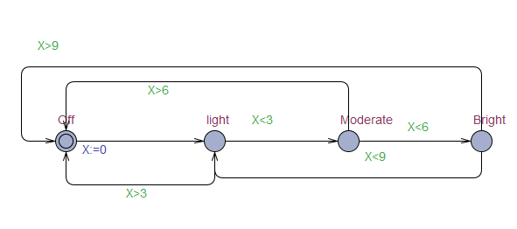

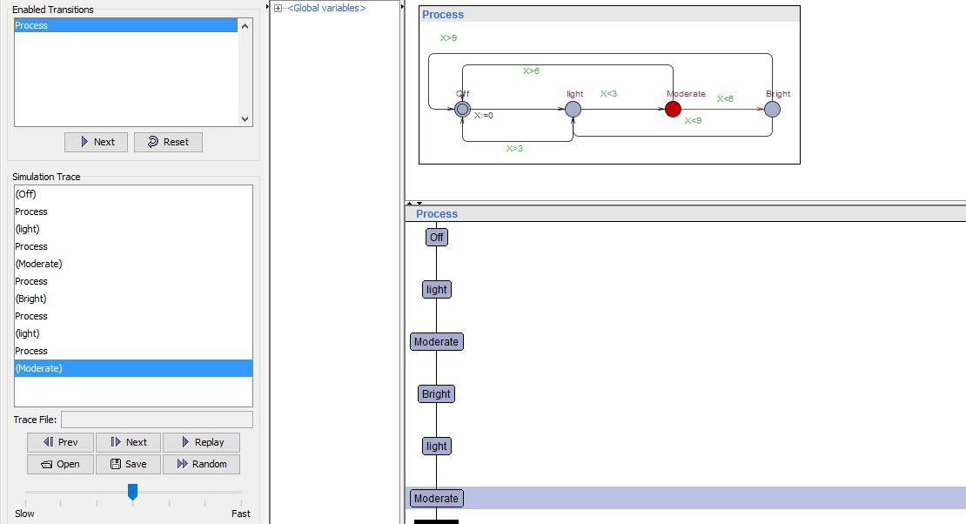

EXPLANATION:

This shows a switch of light with different states , X represents time if person presses an off switch bulb will be on “light” if in next 3 seconds he presses again , it will become “moderate”(more bright than light) and if in the next 3 seconds of moderate it is pressed again , so bright light will be shown . Meaning consecutive presses of switch quickly will move forward and if pressed slowly meaning delay of more than 3 seconds than it will be off. Exception is on bright light if you press within 3 seconds then it can’t move forward because there are no states forward so it will become light but if u press after delay of 3 seconds on bright light it will be turned off like other states.

Question 2: Automated Door

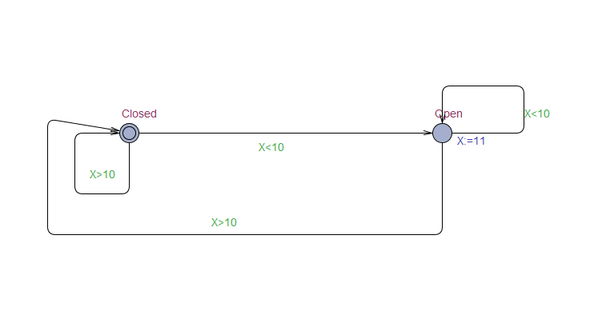

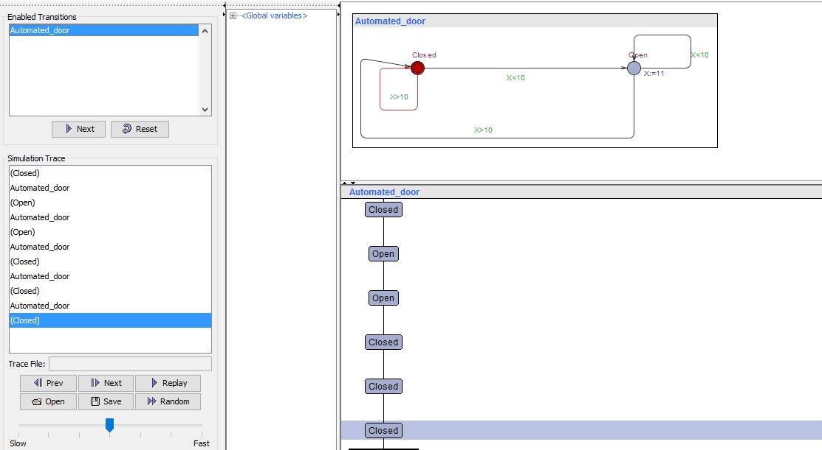

EXPLANATION:

This is an automated door with X representing limit of the door sensor in meters. For example if a person goes to door limit which is 10meters then it will be opened and will stay open till the person leaves , if he goes outside the door’s limit then it will be closed and will remain closed till a person comes within its limit. (Update is done on open edge to show how close works.)